**Bank Management System (CS/2020/044) GNU project**

So in this bank management System We introduce to works the black and white command line interface .So using that bank workers can work productively without any distractions.

1.First Enter the password and the username of the management system

username 🡪 admin

so In the password input we tried to hide it from the viewer to ensure the privacy

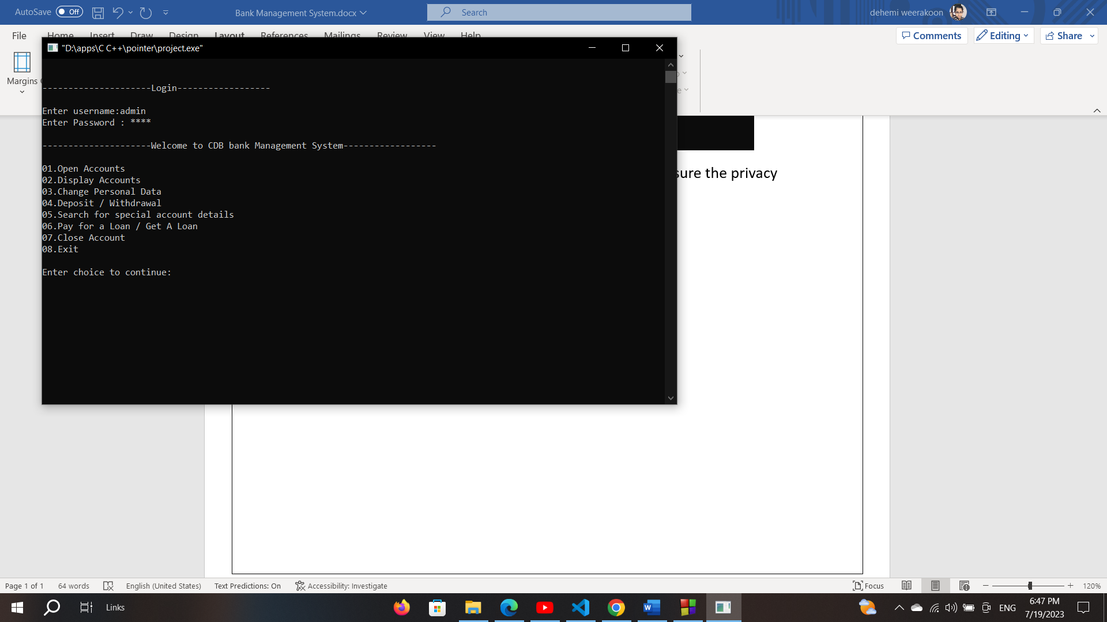

you can see their 8 option to choose

if you choose option As

option “1” Selection

First asks the how many accounts want to create ---> input the number of accounts you want to create:

|  |
| --- |
| How many accounts do you want to open:1 |
| Enter Account NO: ( please enter the account number that contains 10 characters) |
| Enter holders name: (please enter the name of the account holders) |
| Enter holders gender:(please enter the gender of the account holder) |
| Enter holders balance:(please enter the balance of the account balance)  It must be compulsury to balance should above 500 to open a account |
| Enter Account Type:(Saving Account---(S)/Loan Account---(L):  (enter the Acccount type there are two account types  Savings and Loan  If you want a account with no Loan with savings you can Enter -----> S  If you want a account with loan and Savings you can enter ----------->L |

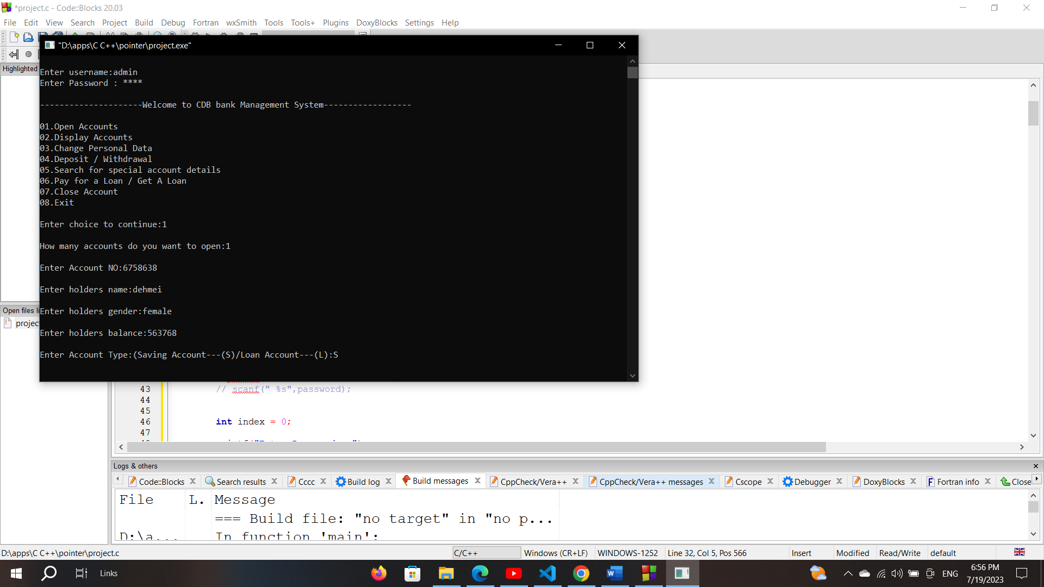

if you select Account Type As “L” cmd asks other 3 quections from the user.

IF THE LOAN IS PERSONAL ---> INTEREST IS:18.5%

IF THE LOAN IS HOUSING ---> INTEREST IS:16%

OTHER LOANS IS ------------> INTEREST IS:28%

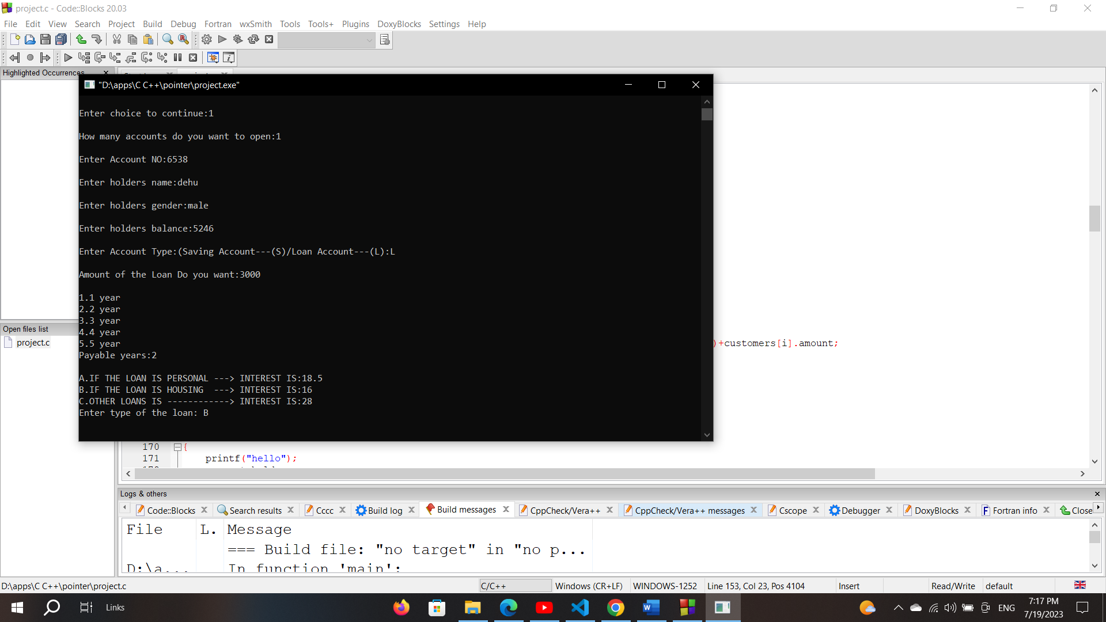

Enter Account Type:(Saving Account---(S)/Loan Account---(L):L

Amount of the Loan Do you want: (Enter the loan amount of the customer’s)

1.1 year

2.2 year

3.3 year

4.4 year

5.5 year

Payable years:(enter the whole number of years to pay the loan )

A.IF THE LOAN IS PERSONAL ---> INTEREST IS:18.5 (limit to 1000000 loan limit)

B.IF THE LOAN IS HOUSING ---> INTEREST IS:16 (limit to 60000000 loan limit)

C.OTHER LOANS IS ------------> INTEREST IS:28 (limit to 20000000 loan limit)

Enter type of the loan: (enter the loan type according to above instructions)

if we enter more than the loan limit of each loan type we have to again enter amount which is right range.

Option “2” selection

This will show the all the data of the account and user details to the bank worker

Option “3” Selection

Option “3” is for the change for the user’s personal data such as name ,gender.

so then asks the correct Account Number.

if account number is found then we can change the name and the gender of the user’s

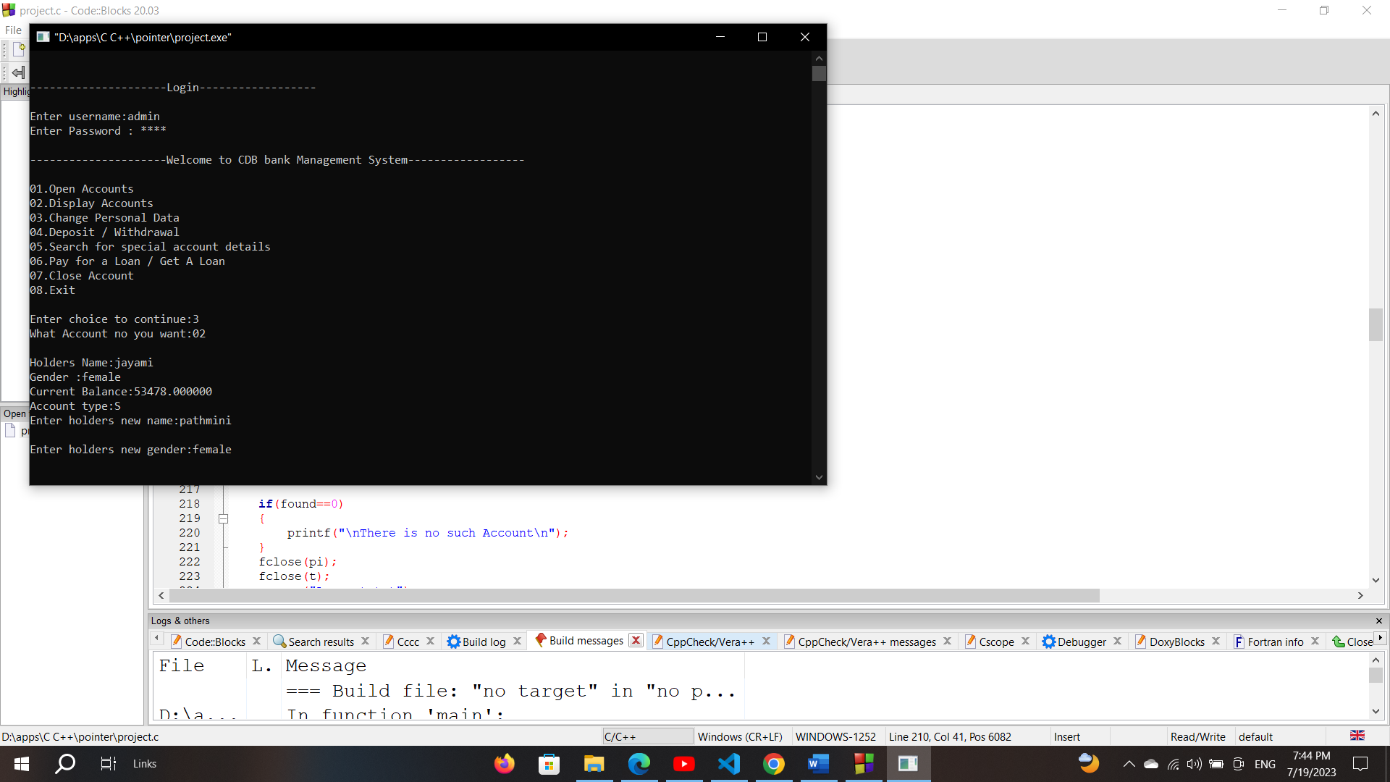

so then if user account not find then we can see the error message .

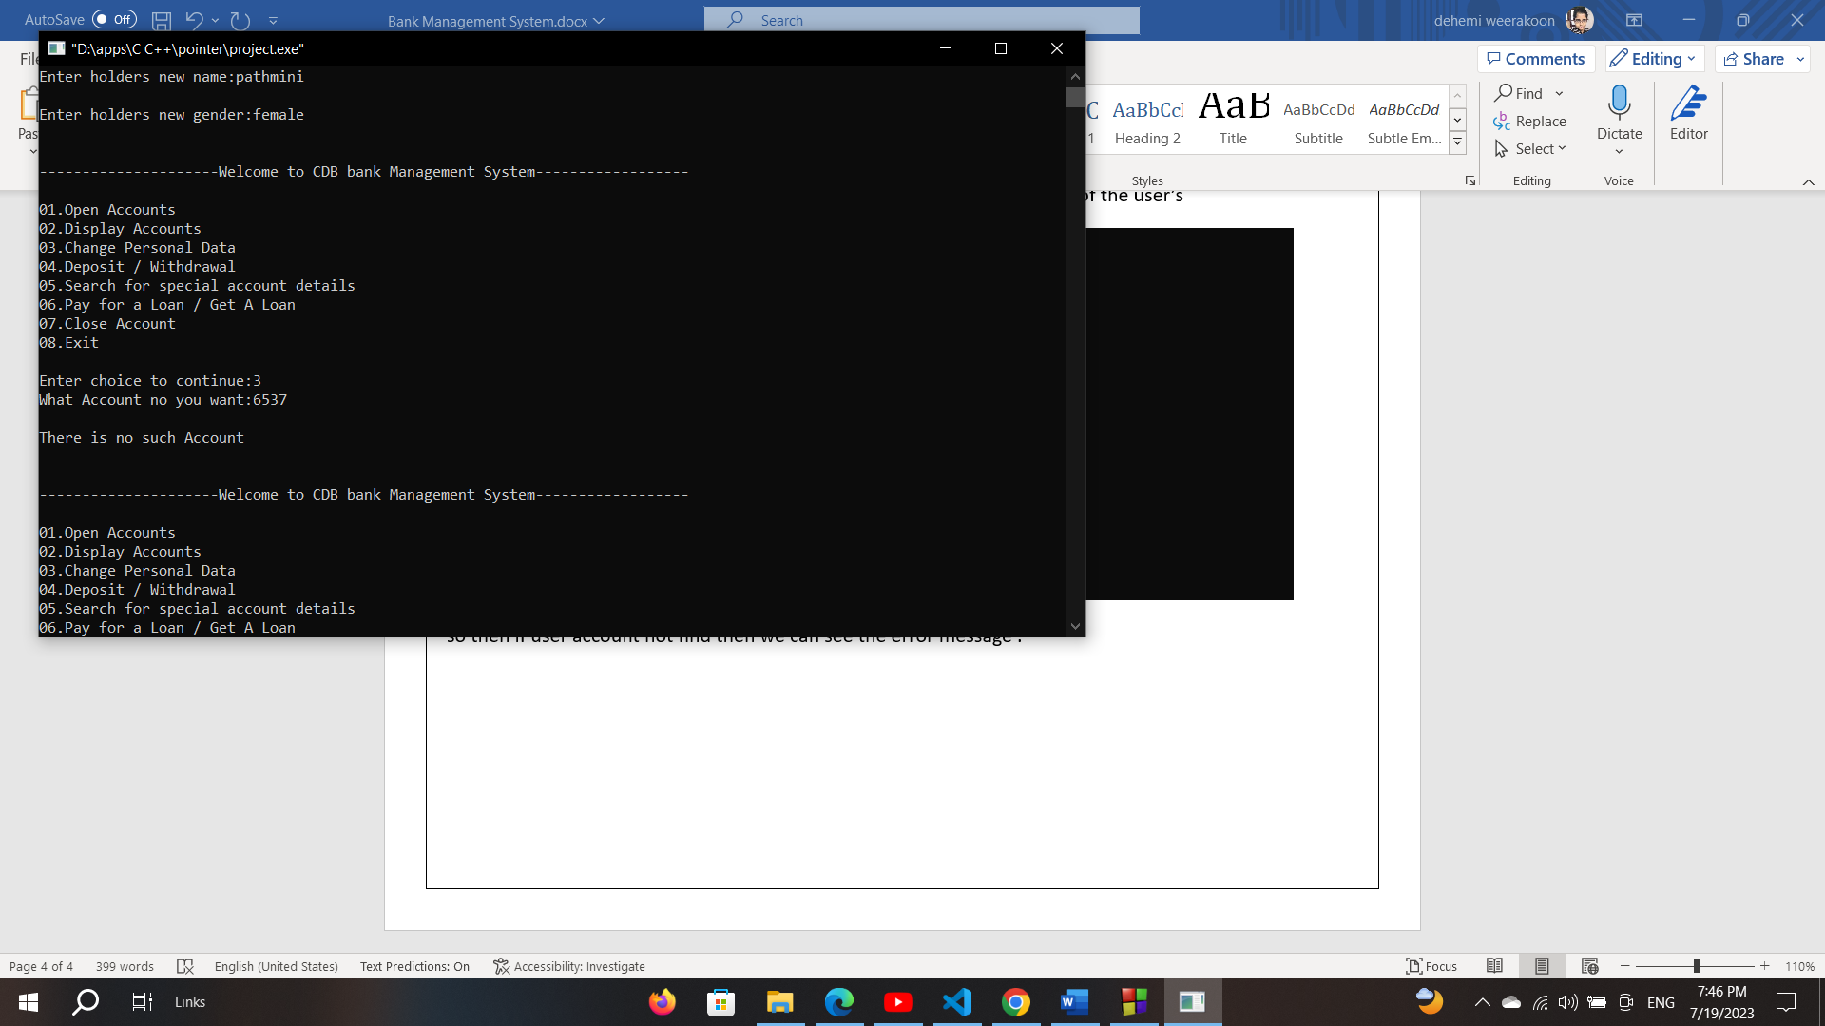

Option “4” selection

if you want to withdraw or deposit, we choose option four.

First ask the Account details then we should enter the account number which contains ten characters.

if account no can be found in the data, we get two option to deposit

1. withdrawal

2. deposit

so, in withdrawal.

if you enter more than the current balance to withdraw or after withdrawl ,account balance is lower than 500 it will show error message.Saying don’t have sufficient amount.

so, we want to enter the withdrawal amount and deposit amount

Option “5” selection

if you want to search some specific account from the system, we can enter option as “5”

first you should enter the account no which contains 10 characters.

if we can’t find the account in the system, we can see error message as

Option “6” selection

if we want to pay for a loan or get a new loan, we choose option 6.

first it asks the account no then you need to enter account no which contains 10 characters.

if account can found on the data set we get two options

1.Apply for a Loan

2.Pay for Loan.

if you want to apply for a loan, please select option as 4 then all details for the loan will ask

(must remember that you cannot apply more than one loan from a single account)

if account no cannot be found it will show error messages

option “7” selection

if you want to remove the bank account you must not have the loan to pay and then if you do not have any

loan to pay so you can remove your account and get your money back from the bank